SAVEETHA INSTITUTE OF MEDICAL AND TECHNICAL SCIENCES
DEPARTMENT OF ELECTRONICS AND COMMUNICATION ENGINEERING

SUBJECT NAME: MICROWAVE ENGINEERING
SUBJECT CODE: ECA1308
STUDENT NAME: T. M. Rishika
REGISTRATION NUMBER: 192412200
EXPERIMENT NO 1

EXPERIMENT 1A — TE10 MODE SIMULATION
A. TE10 Mode Simulation: A WR-90 rectangular waveguide has a = 22.86 mm, b = 10.16 mm and length L = 100 mm. Operate it at f = 10 GHz and excite the dominant TE10 mode in MATLAB. Obtain the E-field and H-field distributions, cutoff frequency fc and propagation constant β. Calculate fc (theory) = c/(2a), β = (2πf/c)√[1−(fc/f)²], and the percentage deviation of simulated fc from the theoretical fc.
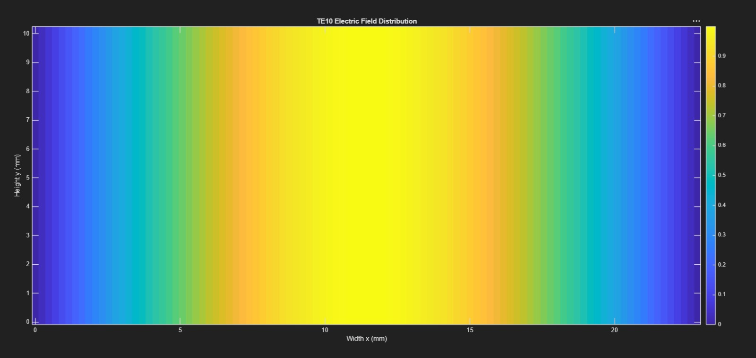
Figure 1. TE10 electric-field distribution.
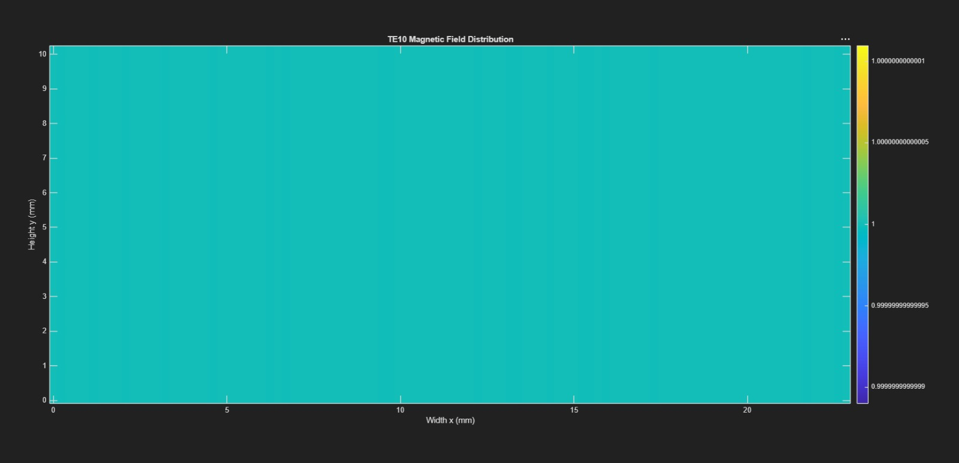
Figure 2. TE10 magnetic-field distribution.
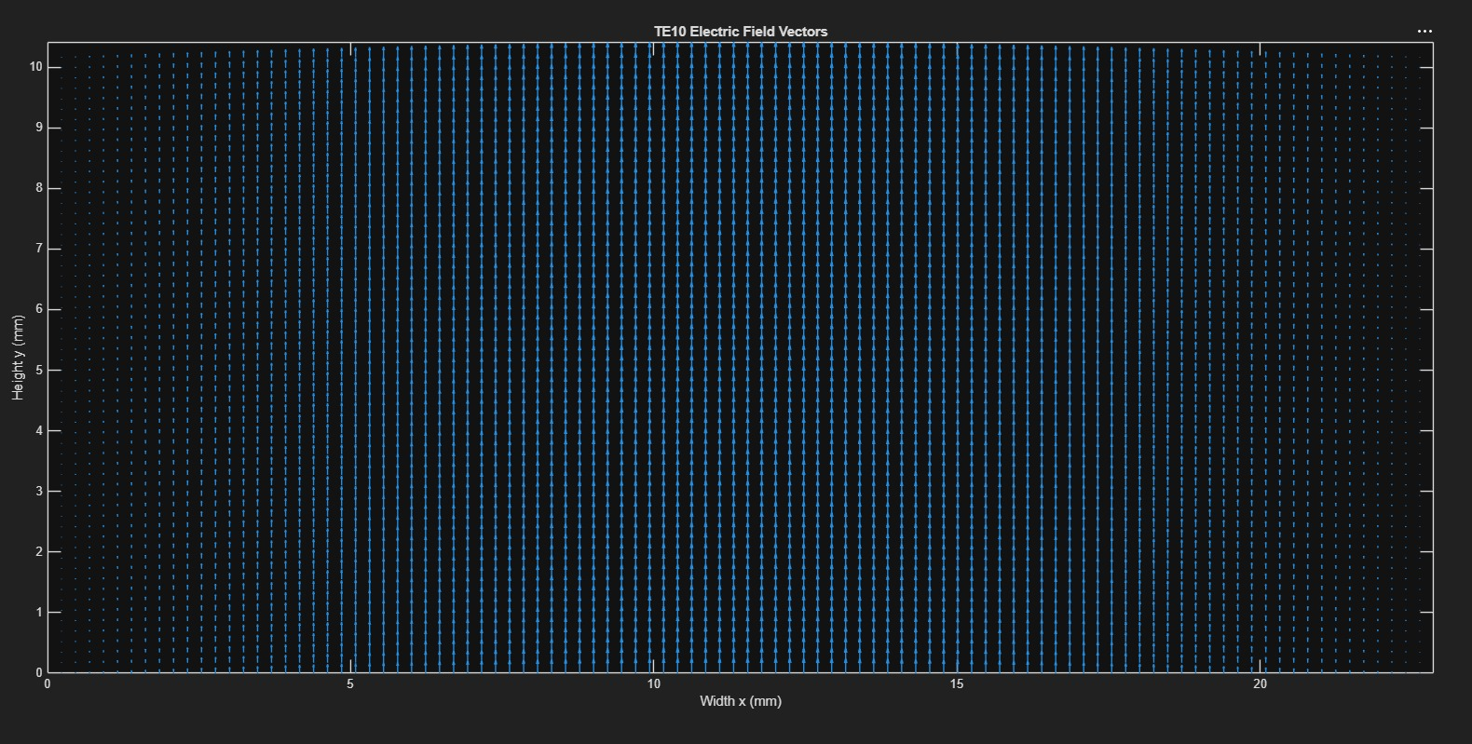
Figure 3. TE10 electric-field vector plot.
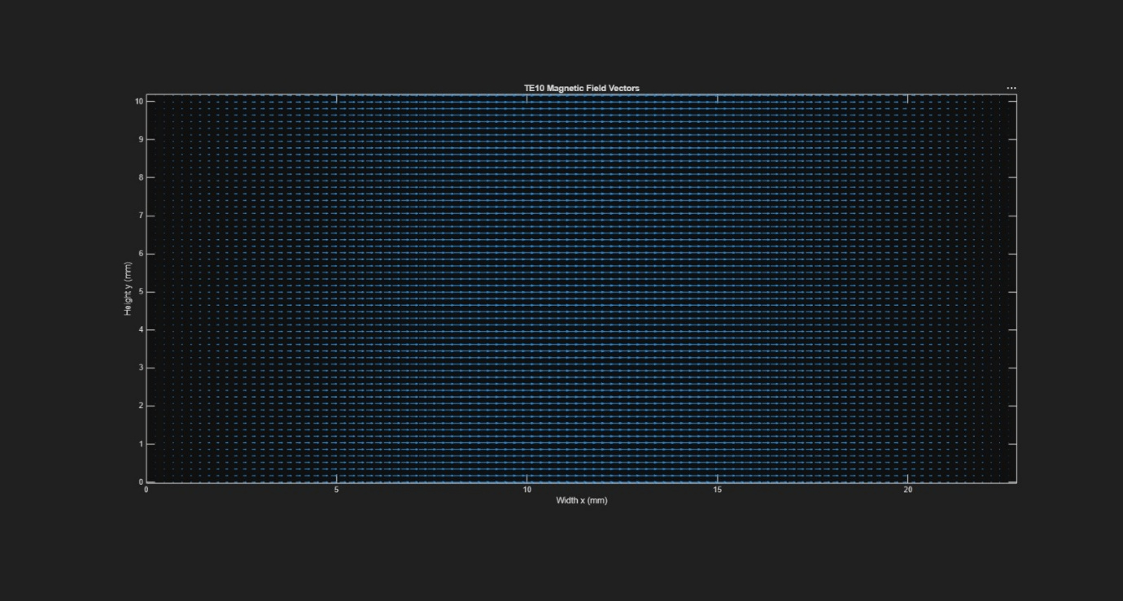
Figure 4. TE10 magnetic-field vector plot.
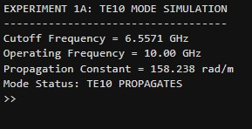
Figure 5. MATLAB command-window output for the TE10 mode.

EXPERIMENT 1B — TE10 VERSUS TM11
B. TE10 versus TM11: Using the same WR-90 waveguide at f = 10 GHz, simulate both TE10 and TM11 modes in MATLAB. Determine fc, β and the E/H-field distributions for each mode. Calculate the theoretical cutoff frequencies using fc(mn) = (c/2)√[(m/a)² + (n/b)²]. Compare the results and justify why TE10 propagates at 10 GHz while TM11 does not.
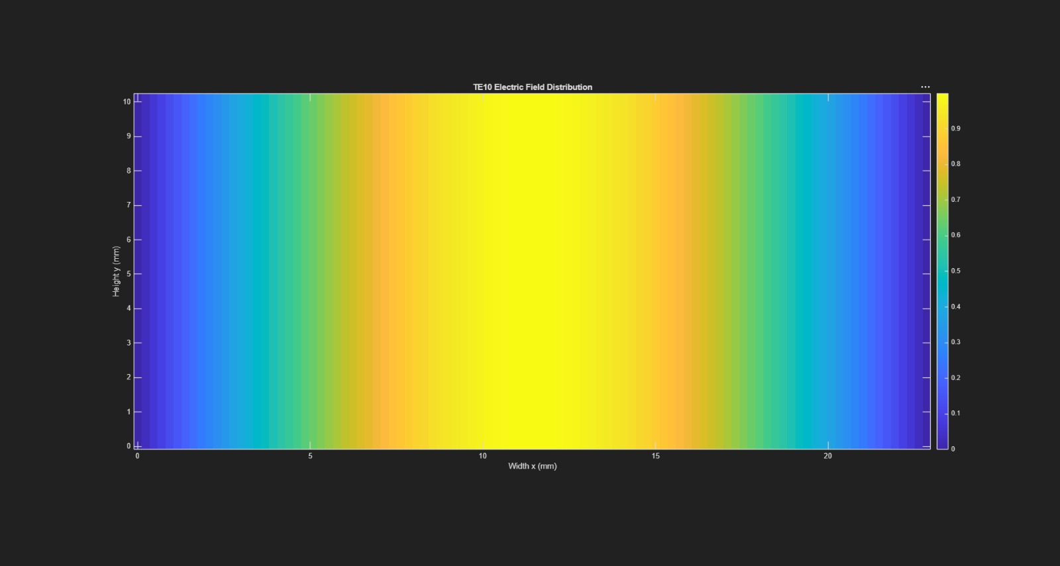
Figure 6. TE10 electric-field distribution for comparison.
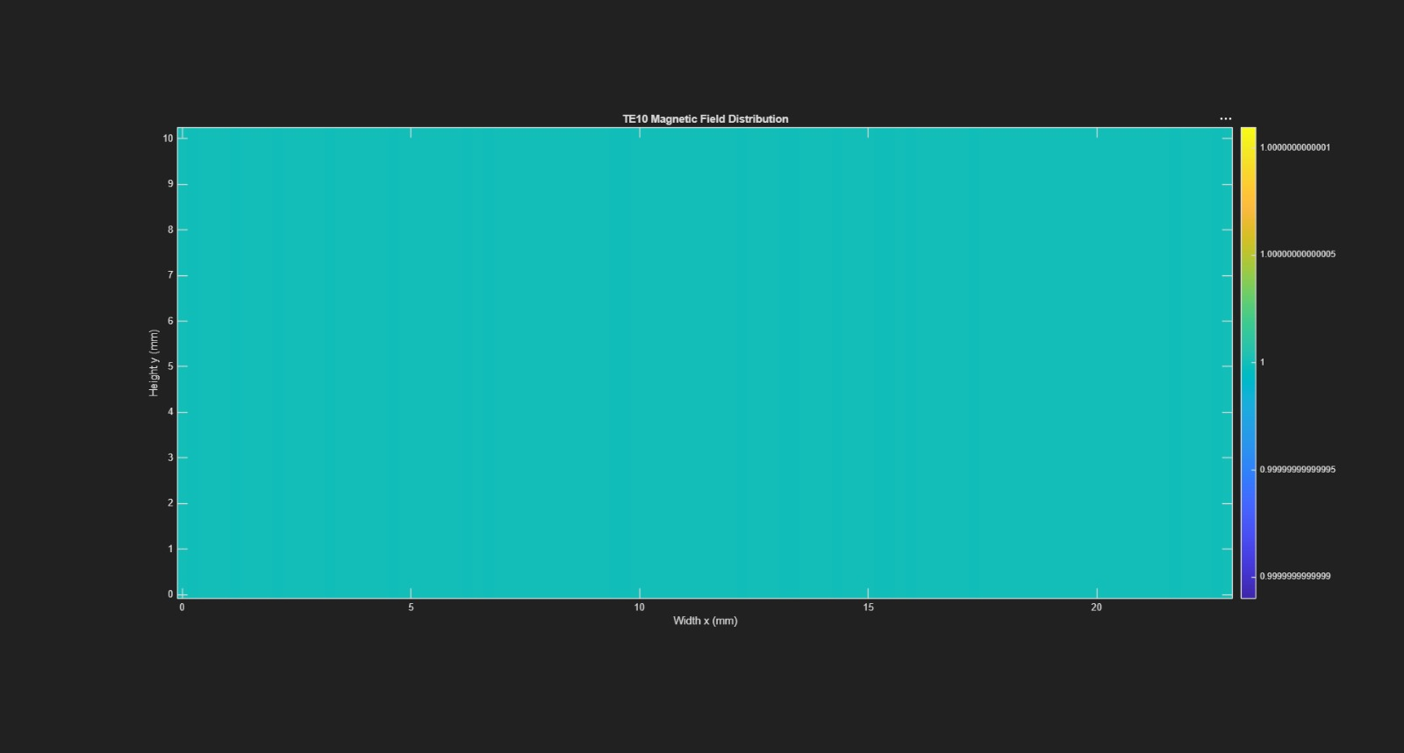
Figure 7. TE10 magnetic-field distribution for comparison.
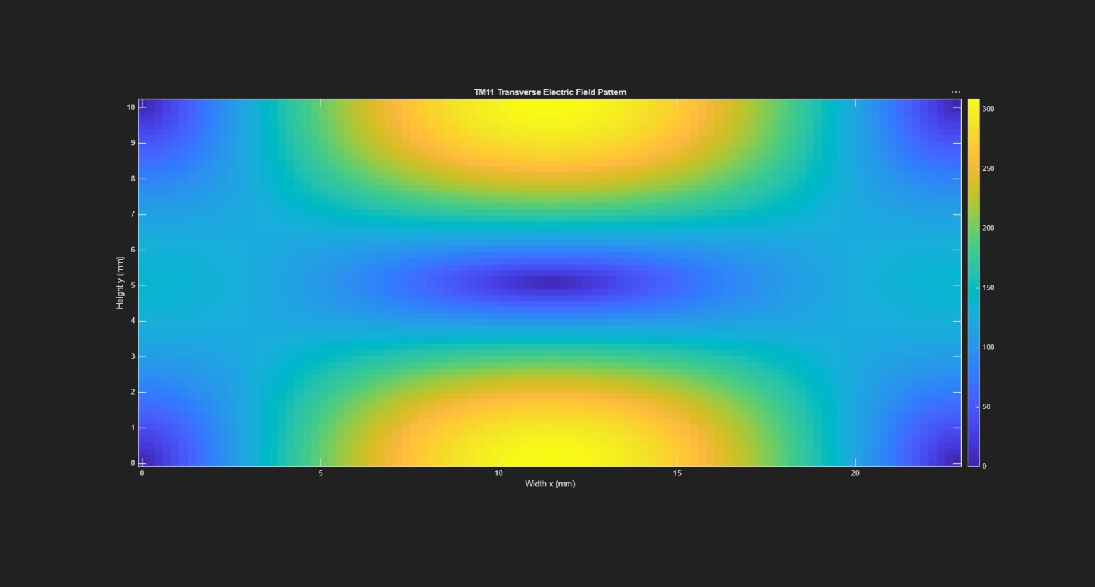
Figure 8. TM11 transverse electric-field distribution.
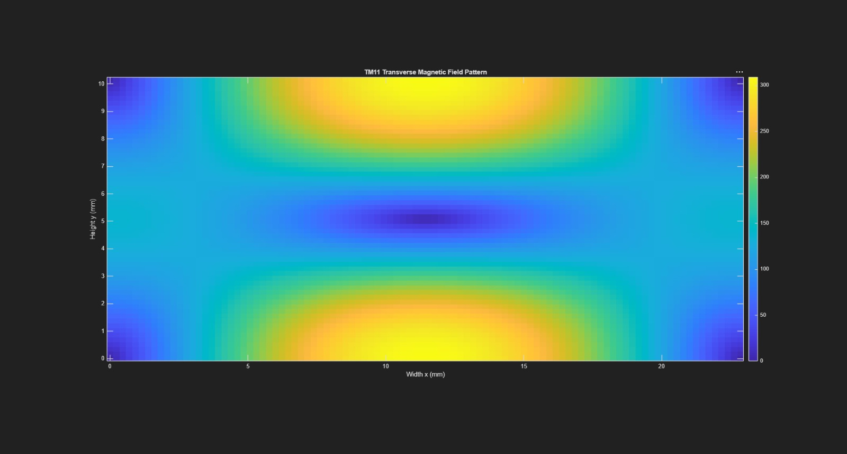
Figure 9. TM11 transverse magnetic-field distribution.
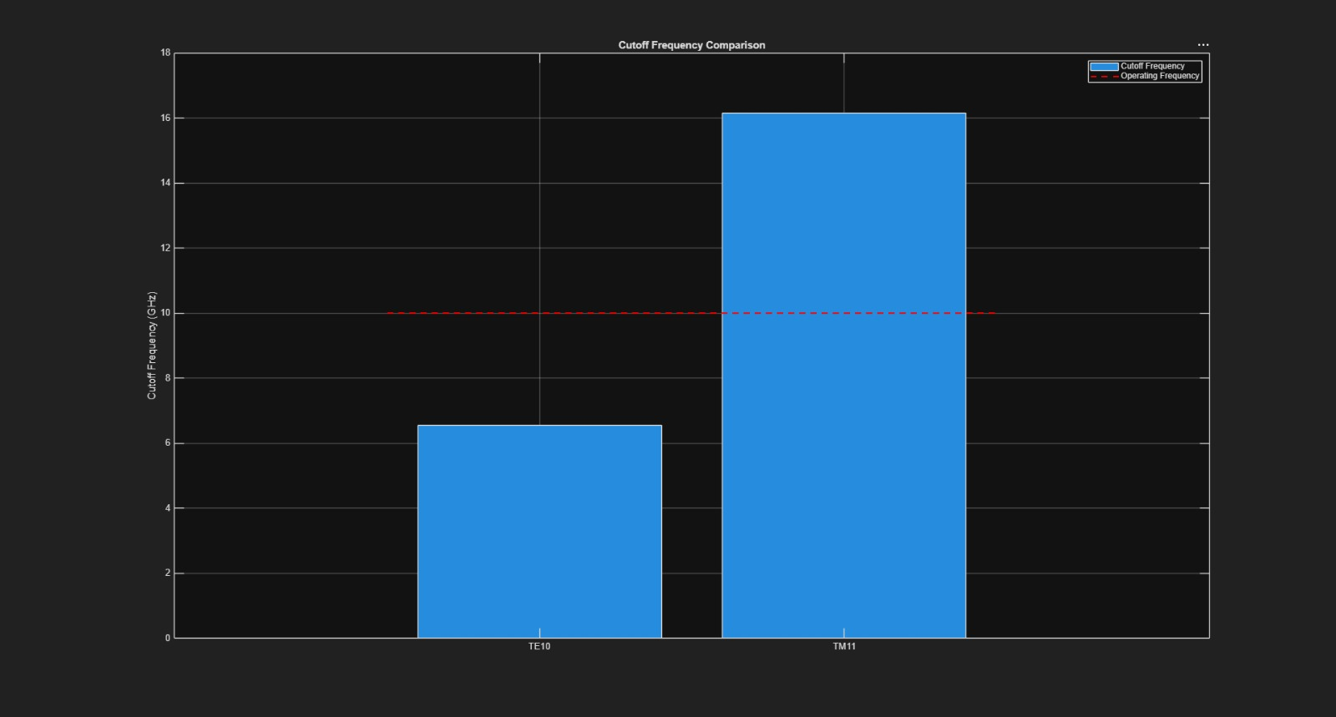
Figure 10. Cutoff-frequency comparison for TE10 and TM11.
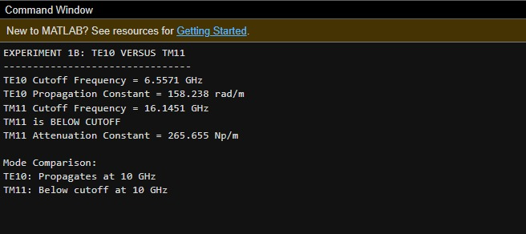
Figure 11. MATLAB command-window output comparing TE10 and TM11.

